To import your song:
- Remember, all songs must be saved in .mp3 format for Photostory to accept them.
- Google search your song.
- Click on the link you’re provided in your search. Chances are the first option will be a YouTube video. Click on it and make sure the song is correct.
- Right click the URL in YouTube and copy it. Then, go to http://www.youtube-mp3.org/
- Paste the URL into the space provided and click Convert Video
- Once converted, click download.
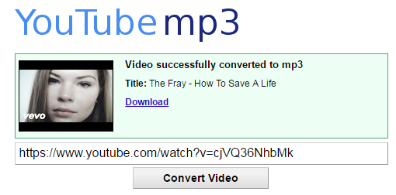
- Once you click download, you’ll see the file downloading in the bottom left corner of the screen. Once it’s finished downloading, click the folder along the bottom of the screen.

- Along the left hand side, click on Downloads. Your .mp3 will be saved here. Save it to your student folder by either dragging and dropping the file, or right clicking it and copying and pasting it to your student folder. THIS IS AN EXTREMELY IMPORTANT STEP, because if you leave it in the Downloads folder, it WILL NOT be available on any other laptop. Once you save the music file to your student folder, you’ll be able to access it from any computer.
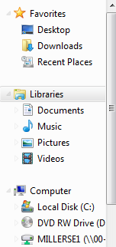
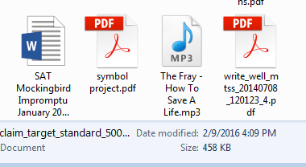

- To begin a new Photostory, open the program and select begin a new project.
- You first must import pictures. Photostory won’t let you continue until pictures are added to the presentation. Click on import pictures and select all the images you wish to include. You can change the order of images by clicking and dragging them.
- Next, you may add text to the pictures. This is how you’ll label the stages of the epic hero cycle, and how you’ll include the appropriate lyrics on those slides.
- On the next screen you’re given the option to customize motion.
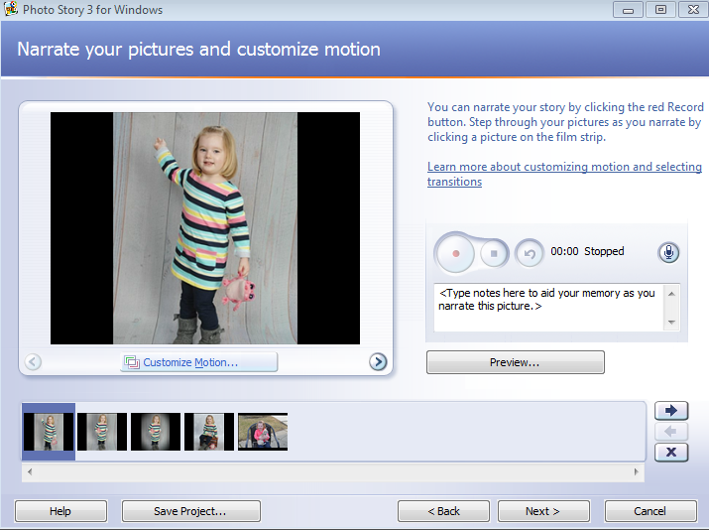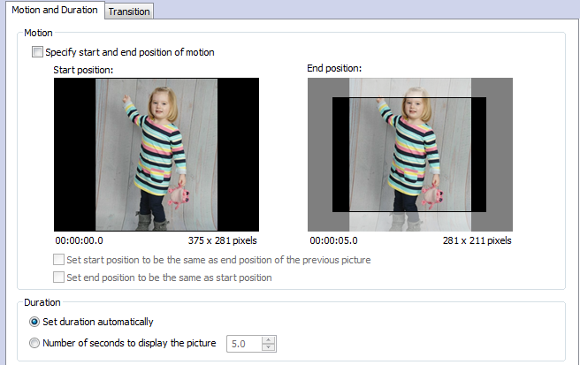
Once here, you can decide how long you’d like each image to be viewed, and set the number of seconds accordingly.
Photostory will automatically set all of your images at an equal duration to fit the length of your song. If you want to change the length of time the audience sees certain images, you can manually set the duration using the screen pictured below.

- On the next screen, you’ll be prompted to add background music. Click Select Music, and then double click your .mp3 file that you’ve already downloaded and saved to your student folder.
- Once you’ve added your music, you’re ready to save.

- It’s wise to save twice: first, save your project as .wmv in the multimedia c drive for your folder, and even better yet, on a flash drive.
- Then, save where it says “save project”. It should save as ‘wp3’. This is a copy of the project in the editing stage and will allow you to return to it to edit it further. Again, save in your folder AND on your flash drive.
- Last, make sure after saving you select the “next” key on the screen below. It will process everything so you can access your work. No need to save again after you select “next”.
- Save on your flash drive as a final back up.
- If, when you save, you receive a message saying you cannot save certain pictures; see the note below about flash drive pictures.
- Be sure to remove flash drives by selecting the icon at the bottom right of your computer which will give you the message you can remove safely. IF you do not do this, you could corrupt your files.
Important Notes About Flash Drive Pictures:
- You must make sure you save the pictures from the flash drive into the project folders. Otherwise your project cannot access these pictures unless the flash drive is available. Make sure you save the pictures from this device in your working project and update as needed.
- Make a copy of the pictures in the flash drive and then put them in the project folder. You may want to make folders within folders to keep things organized.

If all else fails, YouTube offers several video tutorials about how to use Photostory. The link below is one of them, but searching within YouTube will help you to find a number of videos that can help.
https://www.youtube.com/watch?v=06MFnTRqcKM

